Hands-On Lab
Lab Manual
A quick Struts tutorial.

Record of change

*A - Added M - Modified D – Deleted

Effective Date | PIC | A*  M, D | Change Description | New Version
10-Mar-11 | PhucTV1 | A | Create. | 1.0

Contents
A quick Struts tutorial. i
Lab 01: A quick Struts tutorial 5
Lab Objectives 5
Exercise 1 – Download & install Eclipse and necessary plugins. 6
1. Setup the Eclipse and TomCat server. 6
2. Configure the server for Eclipse. 6
Exercise 2 – Create simple portlet application LoginAction. 10
1. Create a Dynamic Web Application. 10
2. Copy lib of Struts to folder “WebContent\WEB-INF\lib. 12
3. Create file struts-config.xml: 12
4. Open web.xml file 13
5. Create index.jsp: 15
6. Create result.jsp 16
7. Create error.jsp 17
8. Create bean LoginActionForm.java to store value of parameter form index.jsp: 18
9. Create LoginAction.java 20
10. Open file struts-config.xml and modify the content like below: 21
11. Build project: right click on project, choose -> Build Project 22
12. Run the web application: 23
Appendix 24
1. Setup necessary environment variables. 24
2. Setup the Apache Tomcat server 6.0.26 25

Lab 01: A quick Struts tutorial
Estimated time to complete this lab: 45 minutes

Lab Objectives
The objective of this lab is to provide an introduction on to set up environment to use struts framework. After completion this lab, you will be able to:
- Set up and use eclipe IDE, TomCat 7.0 to create a project using Struts framework with MVC model
- Have basic knowledge about Struts 1.3.8.

References:
- \\rai-server\Supports\Tools\jPackages\eclipse-jee-galileo-SR1-win32-rocky.zip
- \\rai-server\Supports\Tools\Java\Portlet\Hand-on labs\ HandOnLabs_Portlet_Create Hello Portlet App with Eclipse_v3.0.doc
- www.vovanhaiblog.com
- \\rai-server\Supports\DocCollections\Java\Struts\Struts1&2\ MVC & Struts1.ppt

Exercise 1 – Download & install Eclipse and necessary plugins.
  - Setup the Eclipse and TomCat server.
This lab uses these softwares:
- Eclipse IDE for Java EE Developers
- Tomcat server 6.0.26
- Download Struts 1.3.8 lib( )
Refer more details in Appendix.
  - Configure the server for Eclipse.
- Open the Preferences dialog by going to menu Window > Preferences. Select node Server\Runtime Environment.
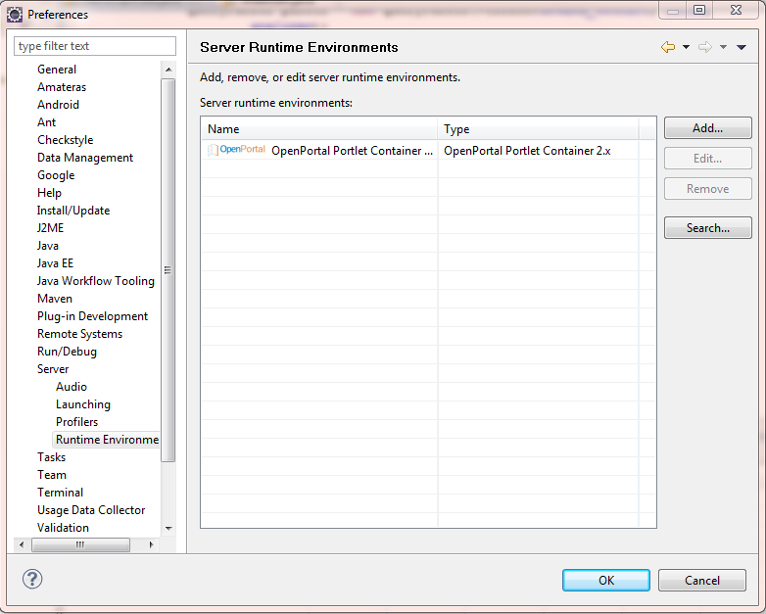
- Click on Add… button.
- In the New Server Runtime Environment dialog, select node Apache\Apache Tomcat v6.0.
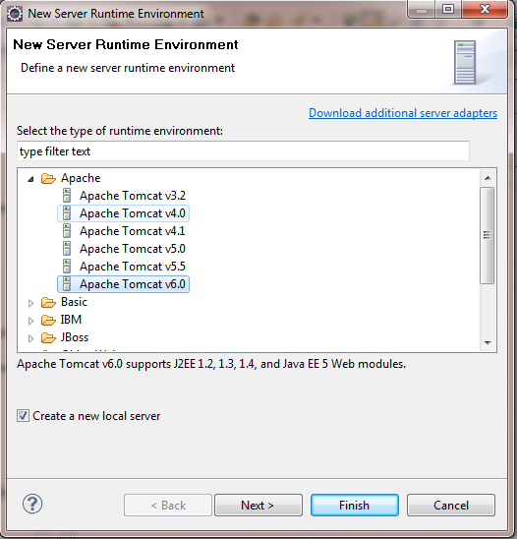
- Click “Next”
Click on Browse… button to select Tomcat Home.
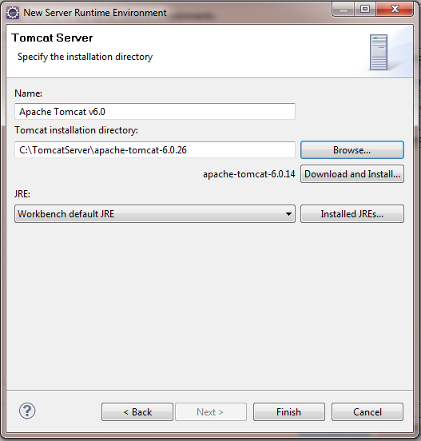
- Click on Finish button.
- The Apache TomCat server v6.0 has been added to server runtime environment.
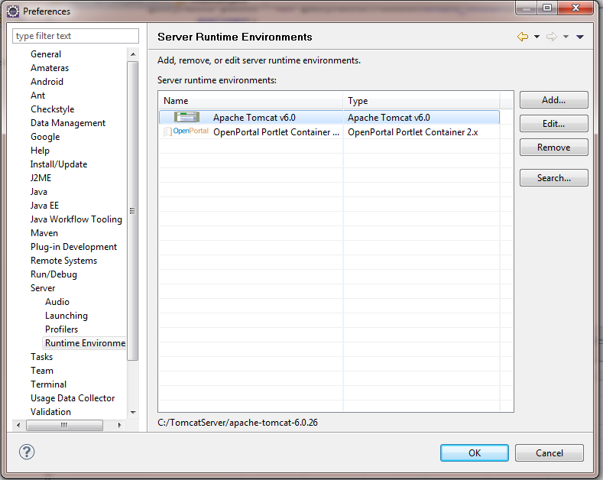

Exercise 2 – Create simple portlet application LoginAction.
      - Create a Dynamic Web Application.
- Goining to menu File > New > Dynamic Web Project.
  - Input the Project name. Click on Next button twice.
  - Select follow the sreen below:
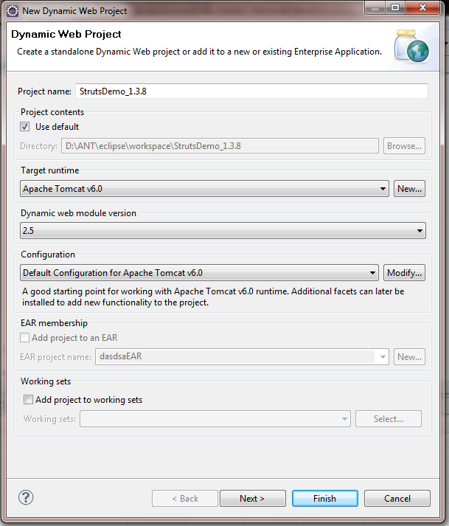

- Click on Finish button. The structure of the project is:
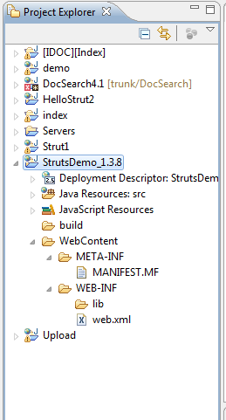
- Copy lib of Struts to folder “WebContent\WEB-INF\lib.

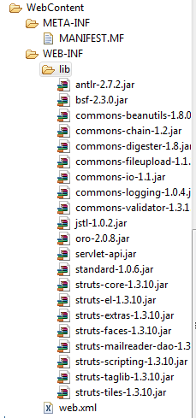
- Create file struts-config.xml:
- Right click on folder WEB-INF, choose New->XML

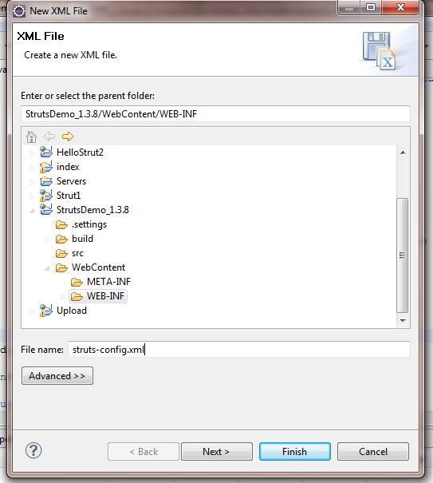
- Click on Finish button.

- Open web.xml file

- Delete all content of this file and replace by the content below
<?xml version="1.0" encoding="UTF-8"?><web-app version="2.5" xmlns="http://java.sun.com/xml/ns/javaee" xmlns:xsi="http://www.w3.org/2001/XMLSchema-instance" xsi:schemaLocation="http://java.sun.com/xml/ns/javaee http://java.sun.com/xml/ns/javaee/web-app_2_5.xsd">
<display-name>Strut1_Demo</display-name>
<welcome-file-list>
<welcome-file>index.jsp</welcome-file>
<welcome-file>index.htm</welcome-file>

<welcome-file>index.jsp</welcome-file>

<welcome-file>default.html</welcome-file>

<welcome-file>default.htm</welcome-file>

<welcome-file>default.jsp</welcome-file>

</welcome-file-list>
<servlet>

<servlet-name>action</servlet-name>

<servlet-class>org.apache.struts.action.ActionServlet</servlet-class>

<init-param>

<param-name>config</param-name>

<param-value>/WEB-INF/struts-config.xml</param-value>

</init-param>

<init-param>

<param-name>debug</param-name>

<param-value>2</param-value>

</init-param>

<init-param>

<param-name>detail</param-name>

<param-value>2</param-value>

</init-param>

<load-on-startup>2</load-on-startup>

</servlet>

<servlet-mapping>

<servlet-name>action</servlet-name>

<url-pattern>*.do</url-pattern>

</servlet-mapping>

<session-config>

<session-timeout>

30

</session-timeout>

</session-config>

</web-app>

All file web.xml work with Struts 1.x always use this structure

- Create index.jsp:
- Right click on folder WebContent,choose New->JSP

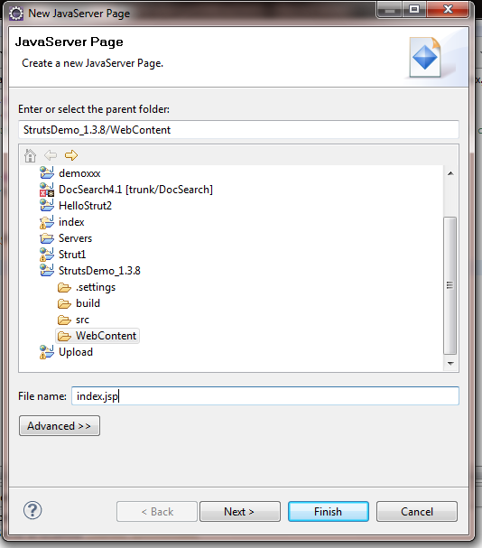
- Click finish
- Mofify content of index.jsp page like content below this
<%@ page language="java" contentType="text/html; charset=ISO-8859-1"
pageEncoding="ISO-8859-1"%>
<!DOCTYPE html PUBLIC "-//W3C//DTD HTML 4.01 Transitional//EN" "http://www.w3.org/TR/html4/loose.dtd">
<html>
<head>
<meta http-equiv="Content-Type" content="text/html; charset=ISO-8859-1">
<title>Welcome</title>
</head>
<body>

<form action="action.do" method="post">
Account <input type="text" name="account" value=""/><br/>
Password <input type="text" name="password" value=""/><br/>
<input type="submit" value="Login"/>
</form>
</body>
</html>

- Create result.jsp
- Right click on folder WebContent,choose New->JSP

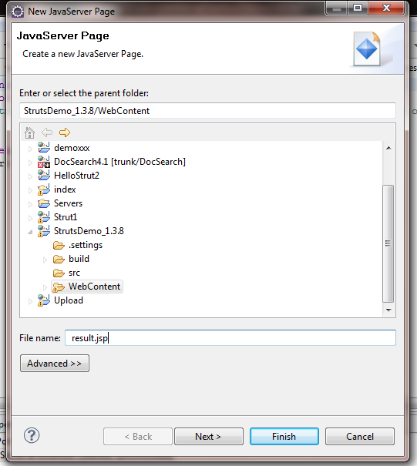
- Click finish
- Mofify content of result.jsp page like content below this

<%@ page language="java" contentType="text/html; charset=ISO-8859-1"
pageEncoding="ISO-8859-1"%>
<!DOCTYPE html PUBLIC "-//W3C//DTD HTML 4.01 Transitional//EN" "http://www.w3.org/TR/html4/loose.dtd">
<html>
<head>
<meta http-equiv="Content-Type" content="text/html; charset=ISO-8859-1">
<title>Insert title here</title>
</head>
<body>
<h1>You are login successfully</h1>
Welcome : ${param.account}
Click <a href="try.do">here</a> to return!!!

</body>
</html>

- Create error.jsp
- Right click on folder WebContent,choose New->JSP

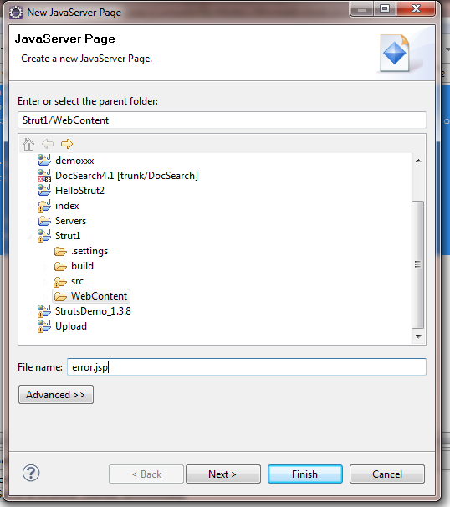
- Click finish
- Mofify content of error.jsp page like content below this

<%@ page language="java" contentType="text/html; charset=ISO-8859-1"
pageEncoding="ISO-8859-1"%>
<!DOCTYPE html PUBLIC "-//W3C//DTD HTML 4.01 Transitional//EN" "http://www.w3.org/TR/html4/loose.dtd">
<html>
<head>
<meta http-equiv="Content-Type" content="text/html; charset=ISO-8859-1">
<title>Error</title>
</head>
<body>
<h1>Invalid account or password</h1>
Click <a href="try.do">here</a> to try again!!!
</body>
</html>

- Create bean LoginActionForm.java to store value of parameter form index.jsp:
- Right click project, choose New-> Class

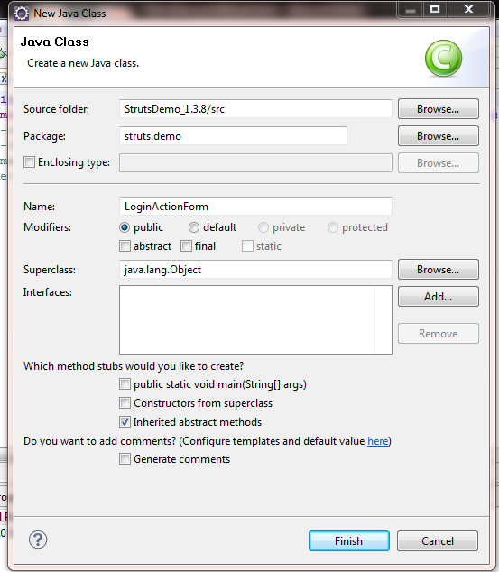

- Modify content of LoginActionForm.java like content below:
package struts.demo;

public class LoginActionForm extends org.apache.struts.action.ActionForm {
private static final long serialVersionUID = -6210614082380637094L;
private String account;
private String password;
public LoginActionForm()
{
this.account="";
this.password="";
}
public String getAccount() {
return account;
}
public void setAccount(String account) {
this.account = account;
}
public String getPassword() {
return password;
}
public void setPassword(String password) {
this.password = password;
}
public LoginActionForm(String account, String password)
{
this.account=account;
this.password=password;
}

}

- Create LoginAction.java
- Rigt click project, choose New -> Class

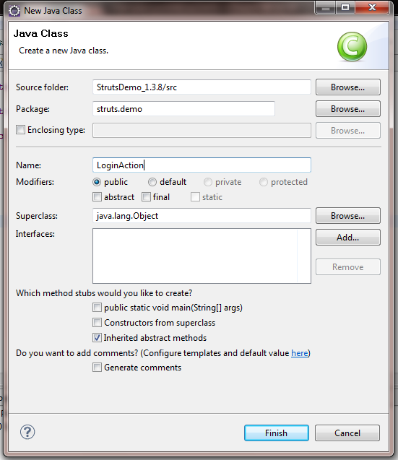
- Modify content of LoginAction.java like content below:

package struts.demo;

import javax.servlet.http.HttpServletRequest;

import javax.servlet.http.HttpServletResponse;

import org.apache.struts.action.ActionForm;

import org.apache.struts.action.ActionForward;

import org.apache.struts.action.ActionMapping;

public class LoginAction extends org.apache.struts.action.Action{

private final static String SUCCESS = "success";

private final static String FAILED = "failed";

public ActionForward execute(ActionMapping mapping, ActionForm form,

HttpServletRequest request, HttpServletResponse response)

throws Exception {
String label = FAILED;
LoginActionForm demo = (LoginActionForm) form;
String account = demo.getAccount();
String password = demo.getPassword();
if ((account.equals("fsoft"))&& (password.equals("123456789")))
{
request.setAttribute("INFO", account);
label = SUCCESS;
}
return mapping.findForward(label);
}
}

- Open file struts-config.xml and modify the content like below:

<?xml version="1.0" encoding="UTF-8" ?>

<!DOCTYPE struts-config PUBLIC

"-//Apache Software Foundation//DTD Struts Configuration 1.2//EN"

"http://jakarta.apache.org/struts/dtds/struts-config_1_2.dtd">

<struts-config>
<form-beans>

<form-bean name="LoginActionForm" type="struts.demo.LoginActionForm" >
<form-property initial="" name="account" type="java.lang.String"/>
<form-property initial="" name="password" type="java.lang.String"/>
</form-bean>

</form-beans>

<global-exceptions>

</global-exceptions>

<global-forwards>

</global-forwards>

<action-mappings>

<action input="/index.jsp" name="LoginActionForm" path="/action" scope="request" type="struts.demo.LoginAction" validate="false">

<forward name="success" path="/result.jsp" />

<forward name="failed" path="/error.jsp" />

</action>

<action forward="/index.jsp" path="/try" />
</action-mappings>

</struts-config>

- Build project: right click on project, choose -> Build Project
- Run the web application:
- Right click on project, choose -> Run As -> Run on Server

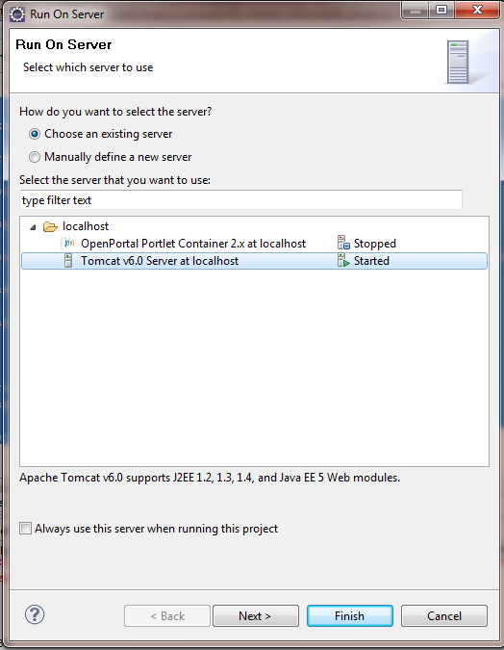
- Click Finish
- Main screen:

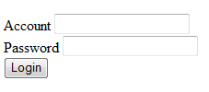
account= fsoft
password = 123456789
Appendix
  - Setup necessary environment variables.
- Create JAVA_HOME variable:
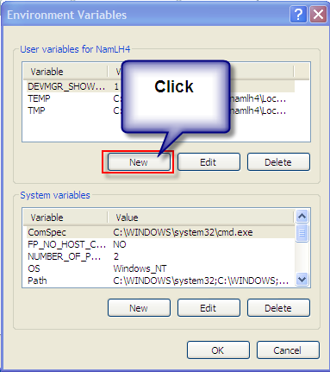
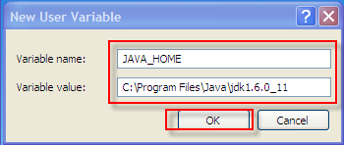
- Open Environment Variables window:

- Edit PATH variable as following:

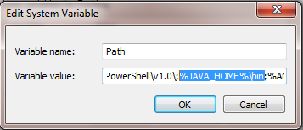
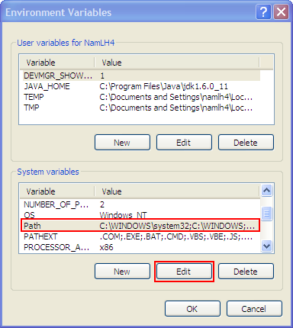

2. Setup the Apache Tomcat server 6.0.26
- Extract file apache-tomcat-6.0.26.rar to folder on your computer(Example: C:\TomcatServer\)

Right-click on the space of source code

